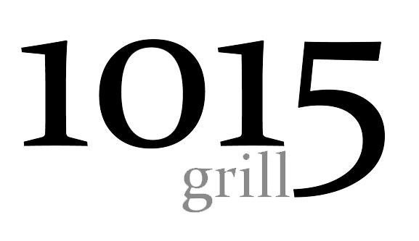
Lunch
Appetizer
1015 Petals- A hefty mound of 1015 Texas Sweet Onion petals hand breaded and lightly fried.-6
Soups and Salads
Signature 1015 Texas Sweet Onion Soup- thinly slice 1015 onions caramelized to perfection in a rich broth topped with fried petals and, accompanied with a grilled sourdough plank. Bowl: 7
Fresh Salad Bar- A variety of your favorites with a 1015 twist. – 8 includes Tea or Water
Entrées
Salmon Salad- The freshest salmon flown in overnight and never frozen served on a bed of mixed greens, roasted corn, house vinaigrette dressing.– Market Price-
Fish & Chips- Hand battered Cod; lightly breaded and fried to a golden brown. Served with English style chips and a homemade Caper lime tarter sauce. -10
Turkey Havarti – Served on a rich wheat bread with lettuce tomatoes and avocado aioli – 8.50
Chicken Salad Sandwich- Roasted chicken salad lettuce and tomatoes on a fresh crossant roll-8.50
Pasta Sarriette- Thick Penne pasta tossed in a sun dried tomato and fresh herb cream sauce. This dish is then topped with thick cut savory sausage and a plank of sourdough. - 10
Ham and Cheddar Melt- Served on a fresh Tollera roll chipotle aioli.- 8.50
1015 Hamburger- On a toasted Tollera Roll with all of your favorites.- 8.50
Lunch
Appetizer
1015 Petals- A hefty mound of 1015 Texas Sweet Onion petals hand breaded and lightly fried.-6
Soups and Salads
Signature 1015 Texas Sweet Onion Soup- thinly slice 1015 onions caramelized to perfection in a rich broth topped with fried petals and, accompanied with a grilled sourdough plank. Bowl 7
Fresh Salad Bar- A variety of your favorites with a 1015 twist. – 8 includes Tea or Water
Entrées
Salmon Salad- The freshest salmon flown in overnight and never frozen served on a bed of mixed greens with your choice of dressing.– Market Price-
Fish & Chips- Hand battered Cod; lightly breaded and fried to a golden brown. Served with English style chips and a homemade Caper lime tarter sauce. -10
Turkey Havarti – Served on a rich wheat bread with avocado aioli – 8.50
Chicken Salad Sandwich- Roasted chicken salad on a fresh crossant roll- 8.50
Pasta Sarriette- Thick Penne pasta tossed in a sun dried tomato and fresh herb cream sauce. This dish is then topped with thick cut savory sausage and a plank of sourdough loaf. – 10
Ham and Cheddar melt- Served on a fresh Toilera roll.- 8.50

1015 Hamburger- On a toasted Toillera Roll with all of your favorites. 8.50

